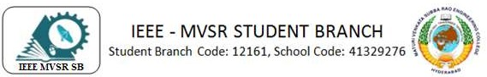

PES GENERAL BODY MEETING-1

A General Body Meeting of IEEE MVSR PES Student Chapter was held on 19th July 2023.The main agenda of this meeting was to plan the future technical, non-technical, social and administrative activities of PES Student Chapter.

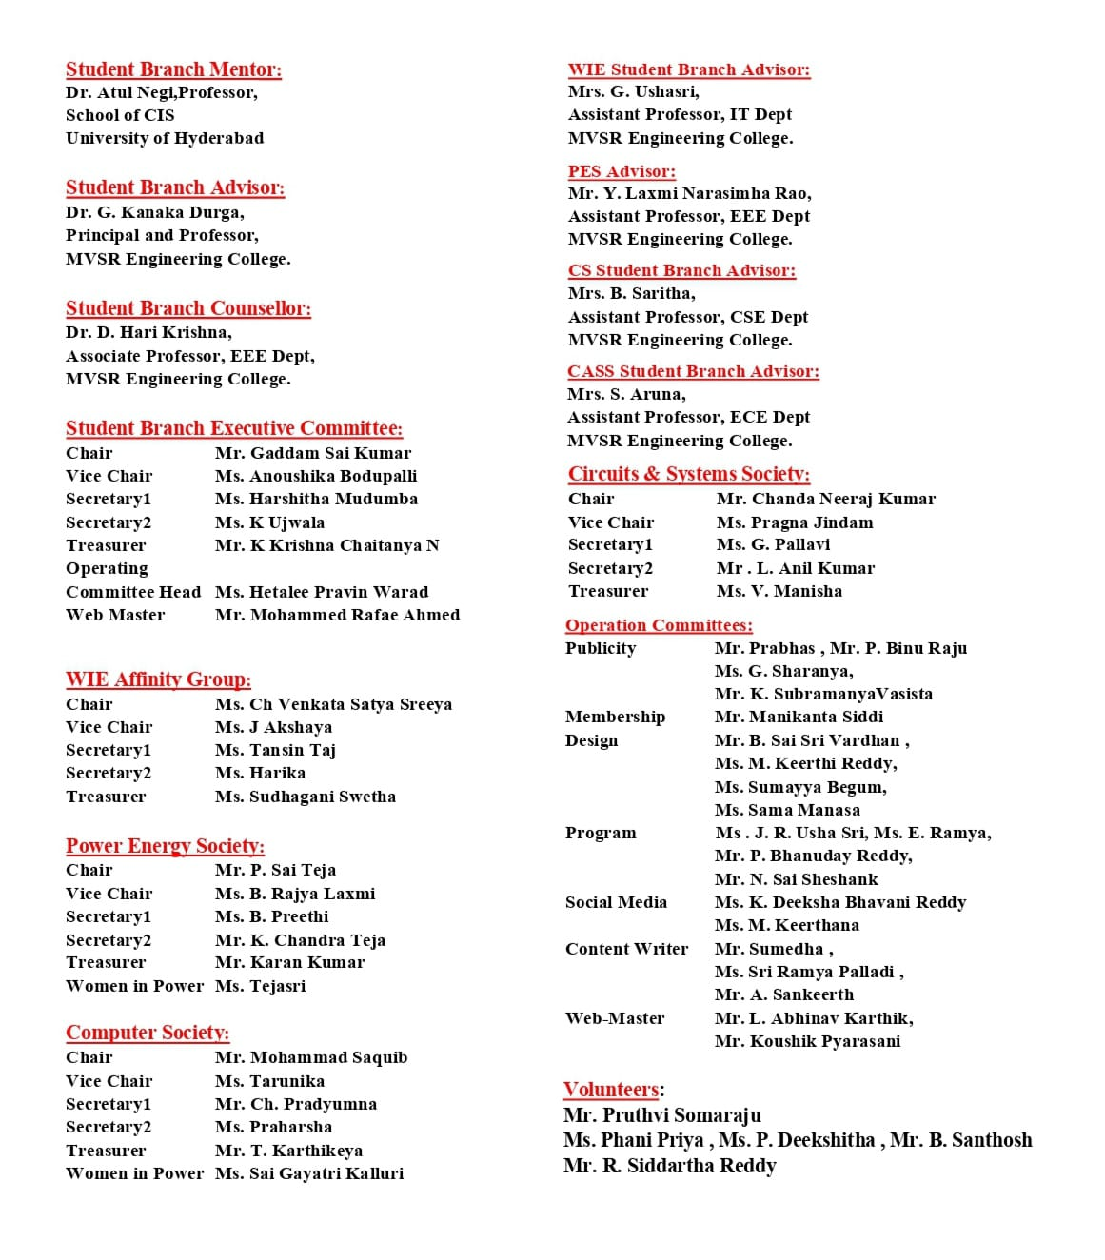

Session Details:
Date: 19th July 2023
Timings: 3:00 pm to 04:30pm
Number of Attendees: 09
Venue: QEEE Hall, MVSREC

The event was commenced by Mr. P. Sai Teja, IEEE MVSR PES Student Chapter Chair by welcoming Dr. D. Hari Krishna, IEEE MVSR SB Counsellor, Mr. Y Laxmi Narasimha Rao, IEEE MVSR PES Student Chapter Advisor, and Mr. I. Narasimha Swamy, EEE department faculty coordinator for IEEE and all the PES Student Chapter Executive Committee members. Then he explain the agenda of the meeting. Later, Dr D. Hari Krishna addressed the meet.

Dr D. Hari Krishna firstly congratulated the newly formed PES Student Chapter ExCom and then started describing about the events to be planned and conducted by the Power Energy Society Student Chapter for the year 2023-24. He also stated that IEEE MVSR PES student Chapter have applied and bagged the prestigious HPSBCP award with the funding of $300 for the year 2022-2023, $351for the year 2021-2022 and $150 for the year 2020-2021. Then, Dr D. Hari Krishna continued with the importance of the collaborative events and how they will help the Power Energy Society Student Chapter. He stated how collaborations can be done at Society level, SB level, Region level and National level. He also gave the insights about the technical events, non-technical events, workshops, and industrial visits could be conducted for this year.
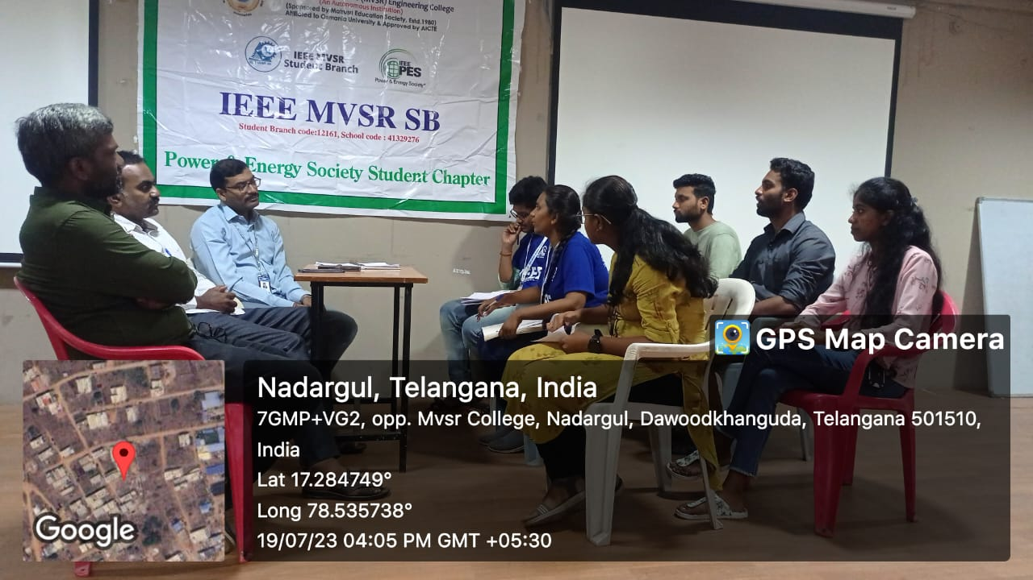
Dr. D. Hari Krishna discussing about the development of IEEE PES Student Chapter

He also highlighted the fact that conducting offline events and workshops was important since the pandemic condition is in control. He also reminded about the ambassador events and asked the ExCom members to be more attentive in conducting those events. He also explained about the importance of improving the participation in the events. He also stated that classroom publicity is important to increase members in IEEE.

Later, Mr. Y Laxmi Narasimha Rao has expressed his gratitude on becoming the IEEE MVSR PES Student Chapter Advisor. He also discussed about the events to be conducted in PES Student Chapter on various workshops on latest areas in Power Systems and Electrical Machines and plan for Field Visits. Further, Mr. I Narasimha Swamy greeted everyone and congratulated the newly formed ExCom. He explained that he was a part of SESREC CELL and took the words of Dr D. Hari Krishna about the collaboration. He said how SESREC and PES Student Chapter can collaborate on various activities like Energy Management and Social Awareness Activities on Energy Conservation, Management of E-waste He also expressed his interest on plantation and workshop on Electric Vehicles. Later,

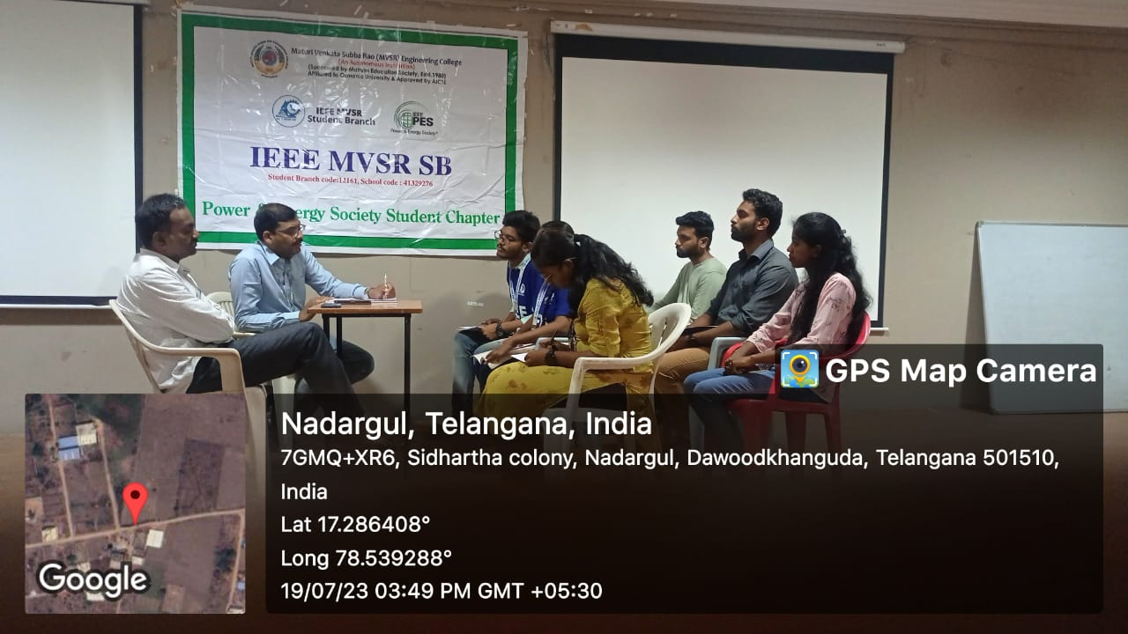
Mr. Y Laxmi Narasimha Roa addressing the gathering

Then the ExCom Members has expressed their ideas on conducting various activities like a Seminar on How to use IEEE website and Student Development Program for class VII to XII, benefits of IEEE, Proper planning to Write Technical Paper, workshop on PSPICE, Multisim software, Field visits and a Podcast on skill or passion. Vote of Thanks by Ms. B. Rajya Laxmi, Vice-Chairperson, IEEE MVSR PES Student Chapter, marked the end of meeting.

List of Attendees:
S.NO | Name of the participant | Roll No | IEEE ID
1 | Dr D. Hari Krishna | Faculty | 90436180
2 | Mr. Y. Laxmi Narasimha Rao | Faculty | 96450801
3 | Mr. I. Narasimha Swamy | Faculty | 97981180
4 | P. Sai Teja | 2451-20-734-316 | 98610543
5 | B. Rajya Laxmi | 2451-20-734-033 | 97501899
6 | B. Preethi | 2451-21-734-304 | -
7 | K. Chandra Teja | 2451-21-734-330 | 99479404
8 | Karan Kumar | 2451-20-734-040 | 98873400
9 | D. Tejasri | 2451-21-734-303 | 98935003

Reported By:
IEEE MVSR SB.

